Using Panopto to Record PowerPoint and Screen Capture Videos

What is Panopto (also known as My Pitt Video) and how do I access it?

The website sometimes referred to as My Pitt Video or Lecture Capture or just Panopto is found at https://pitt.hosted.panopto.com or can be accessed via the my.pitt.edu. portal. It is the cloud storage space that houses all your Panopto videos. Panopto videos can be created using the Panopto Focus Recorder or made through other means and then uploaded to Panopto.
Cloud storage means that your Panopto videos are accessible to stream over the internet in any place that you choose to share them.

How do I use the Pantopo Focus Recorder to record screen capture videos?

Review this tutorial on downloading and using the Panopto Focus Recorder. Note: Instructions are slightly different for Macs and PCs. Be sure to read the instructions that are applicable to you.
This tutorial contains the following information:
Installing the Recorder
Understanding the Program
For Windows
For Mac
Recording Your Video
For Windows
For Mac

What do I do if I have multiple monitors?

Refer to this tutorial if you are using multiple monitors with a Windows device.
Refer to this tutorial if you are using multiple monitors with a Mac device.

Once I finish recording a video, how do I share it?

In your video library, hover over the video you want to share and click on the Share icon. This will open your sharing options (Fig. 1).
Select Change from under Who can access this video to change the sharing option. A pop-up list will appear with the following sharing options.

- Restricted: Share the video with specific people and groups as viewers.
- Your Organization (unlisted): Anyone at your organization with whom you've shared the link.
- Your Organization: Anyone at your organization can find and access the video.
- Public (unlisted): Anyone with whom you've shared the link can access the video.
- Public: Anyone can find and access this video.

Select “Your Organization: Anyone at your organization can find and access the video”

If you have set Who can access this video to any option except Restricted, you can copy and share the link by selecting the Copy Link button that appears. Link copied will appear at the bottom, indicating that you have successfully copied the link
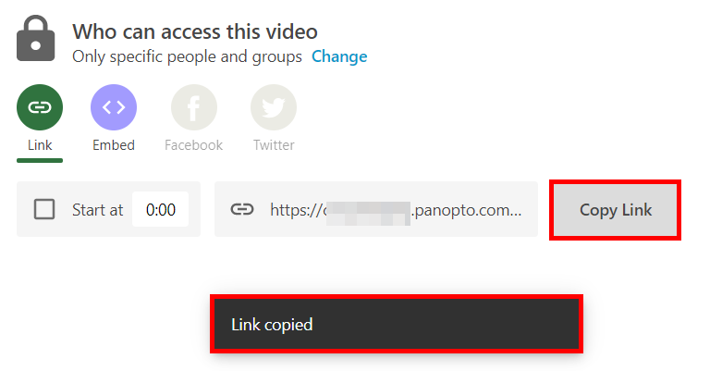
This will be the link you post in InfoReady

If you have specific questions or need one-on-one assistance, email Educational Technology Consulting at edtech@teaching.pitt.edu.

